**PGP Signed Message April 2017**

On April 29 2017, new user came to [#cicadasolvers IRC channel](https://webchat.freenode.net/?channels=#cicadasolvers) and notified us that he found new PGP signed message from cicada 3301.

* <https://pastebin.com/yEiTHhvF>

|  |
| --- |
| [**PGP**](https://uncovering-cicada.fandom.com/wiki/PGP_TUTORIAL)**-Signed Message** |
| -----BEGIN PGP SIGNED MESSAGE-----  Hash: SHA512  Beware false paths. Always verify PGP signature from 7A35090F.  3301  -----BEGIN PGP SIGNATURE-----  Version: CicadaPG v.3301  iQIcBAEBCgAGBQJY5CrwAAoJEBgfAeV6NQkPFvMQAJa3W1K1gFcxFPk90fMFFKKx  oEd7wt26sMYE+FIQmaiC/4Eswmys52+joTUft4oSfHuxT79gg84EhSPSfyn4IpPD  aJivM4DAbh456bTq3Jk2ZUw97fTBLAHLPQFr/2sY6bmhncTHlx/hRUp2DKXcBccI  Zxl/0SuBiEAfFZuIW3hOS7gnoT409z9f7yKsrw+WrLjKiqziOle5Ck7u+EBJn75y  XyKEtRmzaMt/OvQGUV2WNErqZgnoq54/WZwTvlglIeTrK9t8q5KE80ybWthbdLpK  qtaIgPNN/mvX12Xbnhr6dqN1s7VHOZvjLzFu7j/9RrT90XHHTWo9P6GfNTzJkIWC  X+pakY2y+QJXcZhGk3Y7asWX/GGOvbhWnlHIpVsESK2JH5e2YFKusjyW2wTzaNQ6  aBSC+3QwxYVVSsETXR8cC4AaCueRmhmOOGC7gDYFLyKroEFbX4Ii9TllDV6z67Os  hFE3fhGDcoGdi4Hcs4mFUIgGE1TeD9XpogMSi2uXiZylUEaOKsg4spzuiuqI+YLi  8JqcuZ6rQVJ4j1MH95uGuwFzdIIupFLXAZ4NGLz+2Lia+nmq5e08FjVZ+0zb8cnw  17rLIBMwEgEyu2r5pq4ObToGuWvRIcaFOe7bhBNm9ZYR1DUVzD+hJ4XQa5jhi23C  s2bdlE5mbHOLUuNuOm50  =6zQ2  -----END PGP SIGNATURE----- |

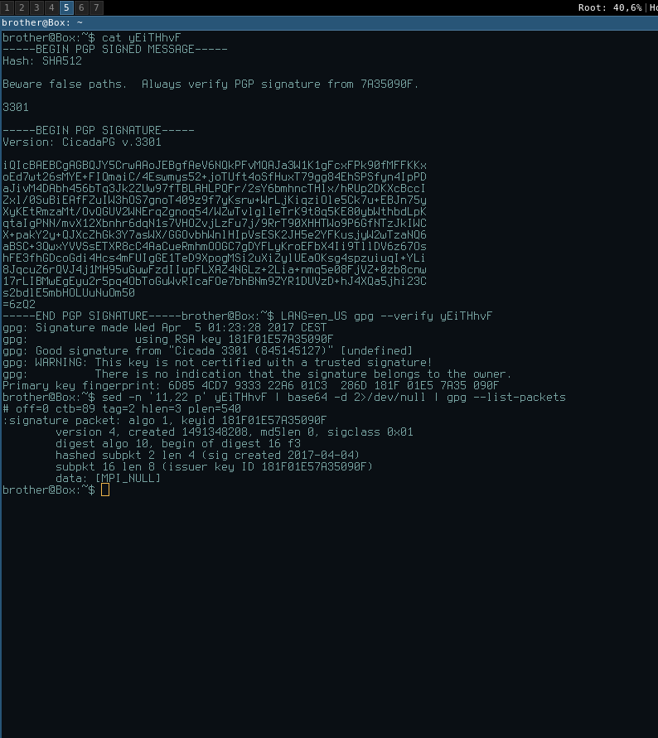

Message is signed with 0x7A35090F key. Date of signature is: *Signed on 2017-04-04 23:23 GMT*

More verifications:

* [prntscr](http://prntscr.com/f273a0),
* [imgur](https://i.imgur.com/1ma7Gwq.png),
* [cubeupload](https://u.cubeupload.com/Hk2qTm.jpg)

At time #cicadasolvers users opened link, pastebin had 113 views.

According to google cache on April on 6 Apr 2017 11:46:25 GMT page had 72 views. [prntscr.com](http://prntscr.com/f28ngf" \t "_blank), [archive.fo](https://archive.fo/aD0JY), [webcache.google](https://webcache.googleusercontent.com/search?q=cache:https://pastebin.com/yEiTHhvF)

Here is how user found it:

<psilynt1> I was looking for the last pgp encrypted message from cicada (you know

the old one linked from twitter that said to verify with pgp)

<psilynt1> searched for

<psilynt1> searched for '7A35090F' on pastebin, sorted by date and there it was...

I thought it was the same, validated it, realized that WASN'T the same, realized

the pastebin date and brotherbin caught me posting it in a discord.

<psilynt1> I posted it in discord, here, then in defango's youtube chat.